**Swimlane Diagram:  
  
Level:** 1.1  
**Name:** Registration & Login  
**Reference:** Activity Diagram Level 1.1

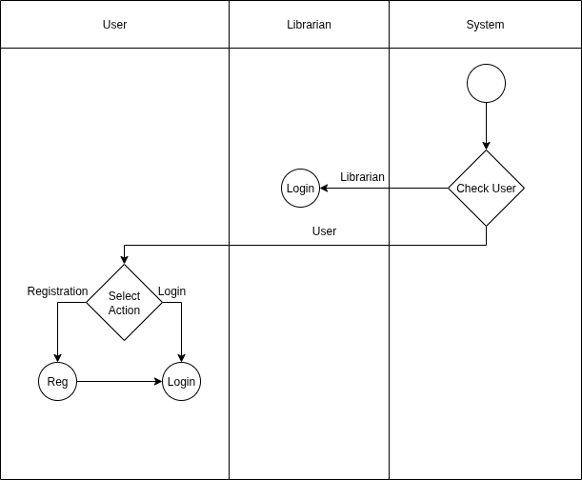

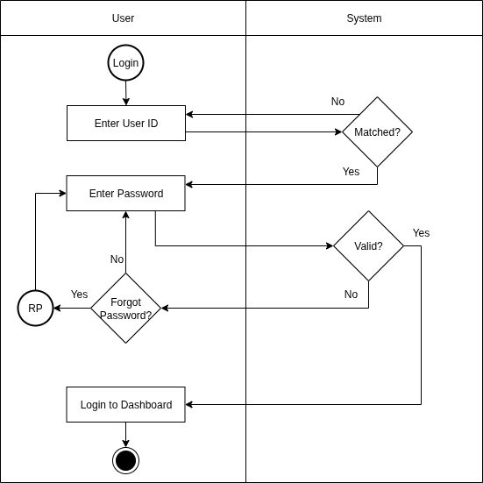

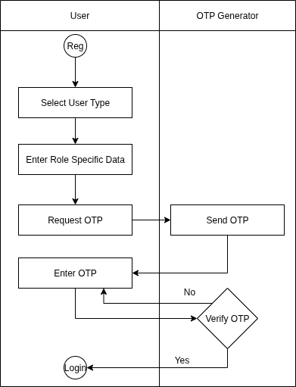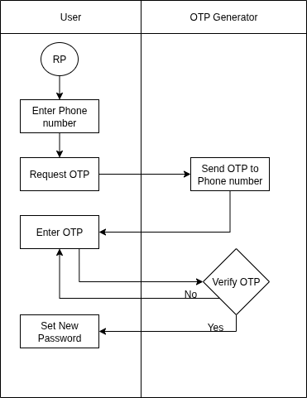

**Level:** 1.2  
**Name:** Dashboard  
**Reference:** Activity Diagram Level 1.2

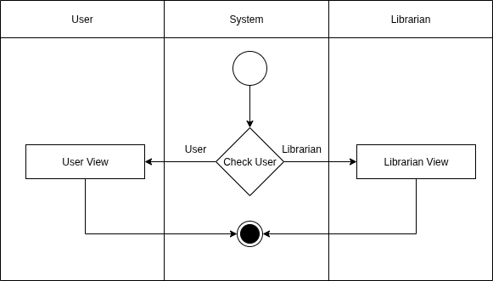

**Level:** 1.2.1  
**Name:** User View  
**Reference:** Activity Diagram Level 1.2.1

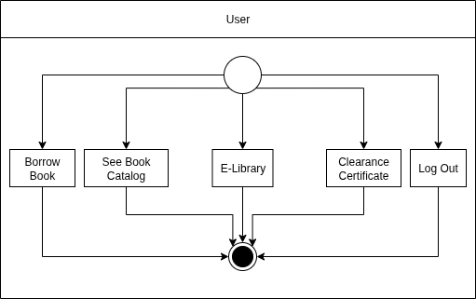

**Level:** 1.2.2  
**Name:** Librarian View  
**Reference:** Activity Diagram Level 1.2.1

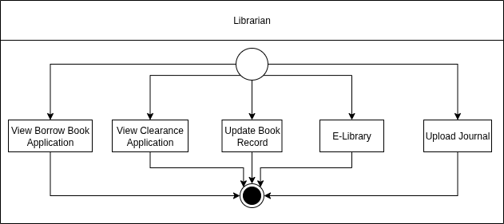

**Level:** 1.3  
**Name:** E-library  
**Reference:** Activity Diagram Level 1.3  
  
 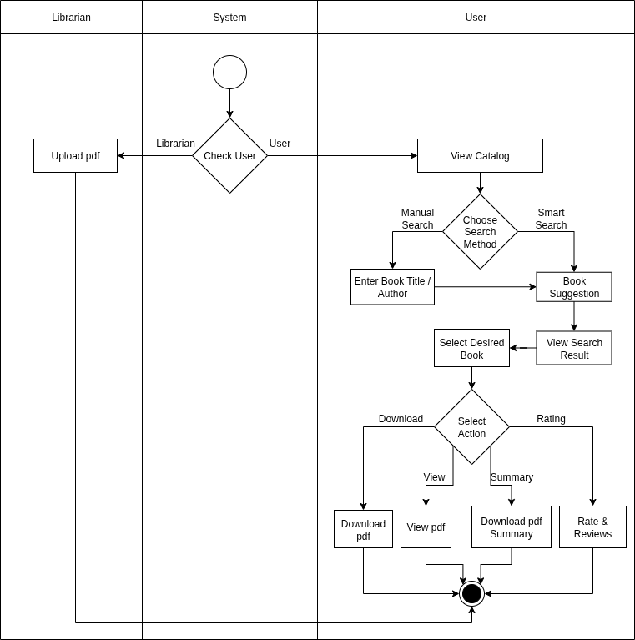

**Level:** 1.4  
**Name:** Borrow Book  
**Reference:** Activity Diagram Level 1.4

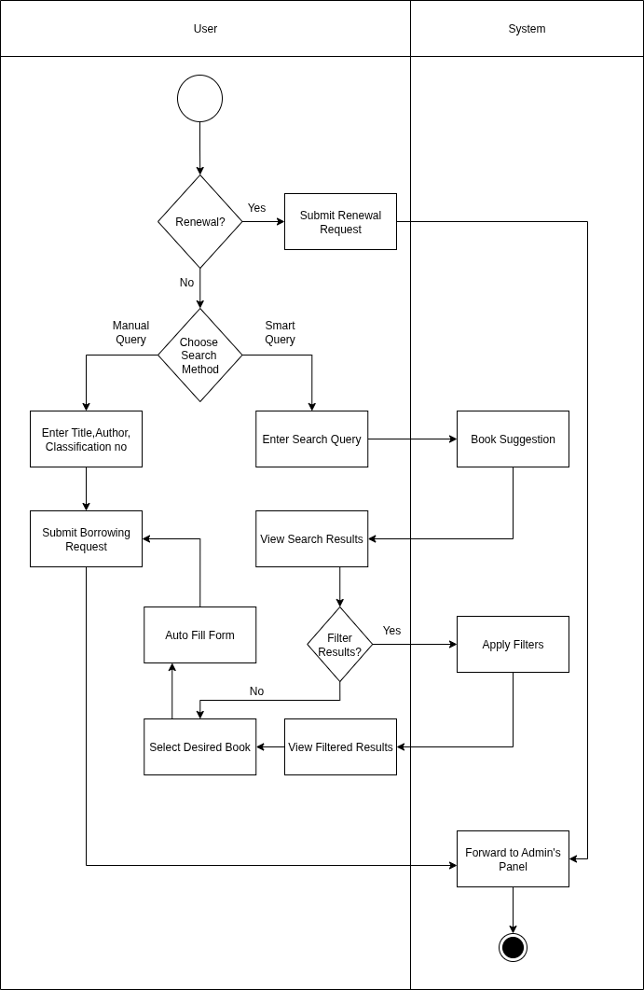

**Level:** 1.5.1  
**Name:** Availability  
**Reference:** Activity Diagram Level 1.5.1  
  
 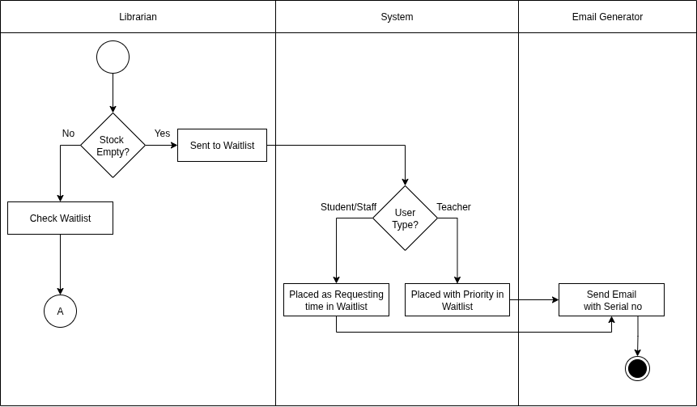

**Level:** 1.5.2  
**Name:** Eligibility  
**Reference:** Activity Diagram Level 1.5.2

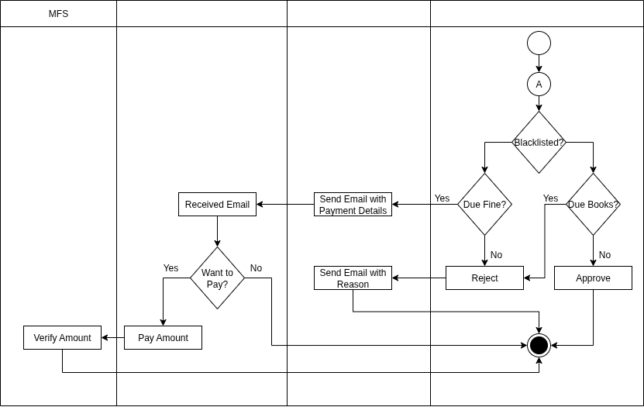

**Level:** 1.6  
**Name:** Clearance  
**Reference:** Activity Diagram Level 1.6

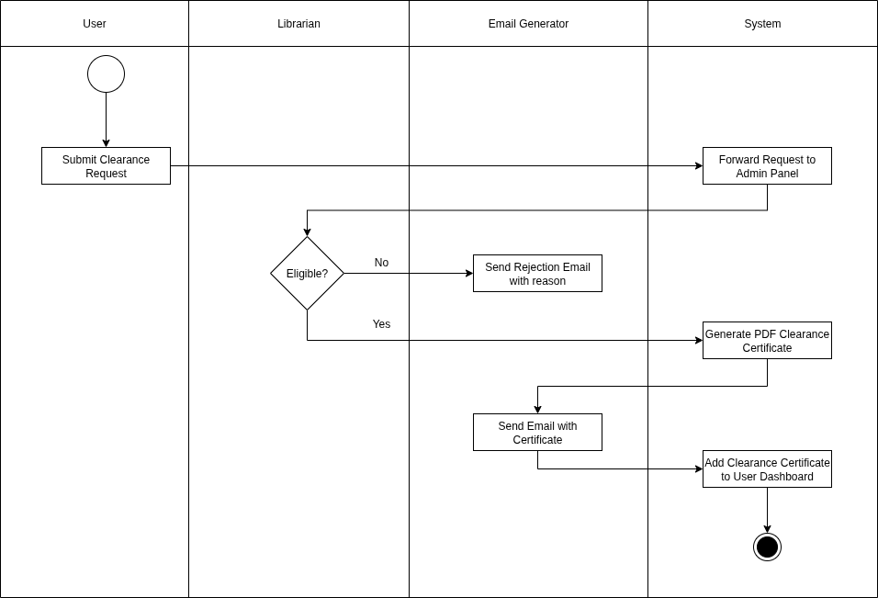

**Level:** 1.7  
**Name:** Eligibility  
**Reference:** Activity Diagram Level 1.7

